- Find the area of the region between two curves below.
$$y=xy=x^{2}-2$$

- Find the area of the region between two curves below. (Hint: the answer is not 0)
$$y=x^{3}y=x$$

- Find the area of the region between two curves below.
$$y=2x^{2} \\ y=x^{2}+4$$

- Given the function of the curve below, find the volume of the solid generated by rotating the area (A) about the x-axis.
$f\left(x\right)=4-x^{2} 0≤x≤2$ 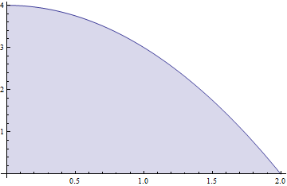 There is an A in the center of blue in picture.

- Similar to finding the area bounded by two functions, you can also find the volume bounded by two functions and rotating its area about the x-axis. Assume f(x) represents one function and g(x) represents the other and that f(x) is greater than g(x). Then you find the volume by integrating the following:
$$V=\int_{a}^{b}{π[\left(f{\left(x\right)}^{2}-g{\left(x\right)}^{2}\right]dx}$$

Find the area bounded by the two functions below, between x = 0 and x = 1.
$$f\left(x\right)=\sqrt{x}g\left(x\right)=x^{2}$$

